NAVVIS CoreoView

User’s Guide

December 2019
Version 1.00

[Company Information]
Navvis & Company is a solutions firm assisting physicians and health networks with health management
Real Life.
Life Changing.
Changing Healthcare.

[Edition Notice]
NAVVIS CoreoView User's Guide Release 1.00.

[Copyright and third-party information]
Copyright © 2019 NAVVIS & Company, LLC. All rights reserved.

[Disclaimer]
Sample names and persons used in this document are purely fictitious and does not refer to real names or persons.
This user's guide has been created with utmost care, nevertheless, it is not guaranteed that this document is error free.
No part of this document may be reproduced or transmitted in any form or by any means, electronic or mechanical, for any purpose, without the express written approval of Navvis & Company.

Table of Contents
1 [Chapter Name / Topic Name] 2
1.1 [Section 1] Example: Stage 1 of the process 2
1.2 Create a new group for the group-type [SAMPLE] 3
2 [Chapter Name / Topic Name] 6
2.1 [Section 1] Example: Stage 1 of the process 6
2.2 [Section 2] Example: Stage 2 of the process 6
2.3 [Section 3] Example: Stage 3 of the process 6
3 Chapter Name / Topic Name 8
3.1 [Section 1] Example: Stage 1 of the process 8
3.2 [Section 2] Example: Stage 2 of the process 8
3.3 [Section 3] Example: Stage 3 of the process 8
4 Appendices 10
5 Glossary 11
6 Index 12

Preface
Welcome to the Release 1.00 of the NAVVIS CoreoView User’s Guide.
This user’s guide covers the information to use the CoreoView Application effectively.
It contains detailed information about the following features:
- Feature 1
- Feature 2
- …...........
- Feature n
This preface explains how this user’s guide is organized.

[Chapter Name / Topic Name]
[Introduces the topic and its purpose, highlighting key features and benefits.]
[Gives an overview of what this topic contains and covers.]
[Provides a concise description of the overall processes that this chapter covers]
[Insert the workflow diagram, if applicable]

[Section 1] Example: Stage 1 of the process
[Provides a description of the feature or the functional that this section covers.]
[Insert the workflow diagram, if applicable]
[Provide examples as applicable.]
[Provides the step-by-step instructions / procedural steps for the user to perform the task. That is, the user should be able to achieve the objective by using the functionality of the application.]
[Procedural steps to perform the task:]

- Step
- Step
- Step
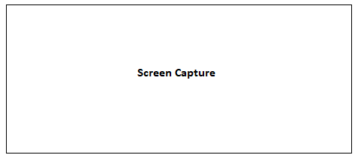
Figure xx:
- Step
- Step
- Step
Use the bulleted list / Unordered list within a Step to list the available options of a drop-down field.
- Option 1
- Option 2
- Option 3
- Step
- ……….
[Provide examples as applicable.]
[NOTES, CAUTIONS, and WARNINGS provide any relevant or supplemental information about consequences of performing a step incorrectly.
Place warnings before the step to be taken. Notes may be placed either before or after the corresponding step.]

[Sub Section 1]
[As a documentation best practice, all important information must be included under Heading Level 1 and Heading Level 2.]
[However, during the course of content development, we can consider including any appropriate information under this sub section, as suited.]

Create a new group for the group-type [SAMPLE]
The CoreoView application provides the following three groups to categorize patients based on the care facilities that they are provided with.
- Acute care: Acute care groups include emergency department, intensive care, coronary care, cardiology, neonatal intensive care and so on.
- Post-Acute Care (PAC) network: Under this care group, patients are cared with skilled nursing facilities, inpatient rehabilitation facilities, long-term acute hospital facilities among others.
- Cross continuum: Under this care group, patients are cared at their home locations and are served by home-health and outpatient services.
Follow these steps to create a new group in the CoreoView application:
- Click the Settings menu in the left pane on the CoreoView home page.
- Click the Add button under the Groups tab. The Add Group tab page opens.
- Select the type of group from the following options:
- Acute Care
- Post-Acute Care Network
- Cross Continuum
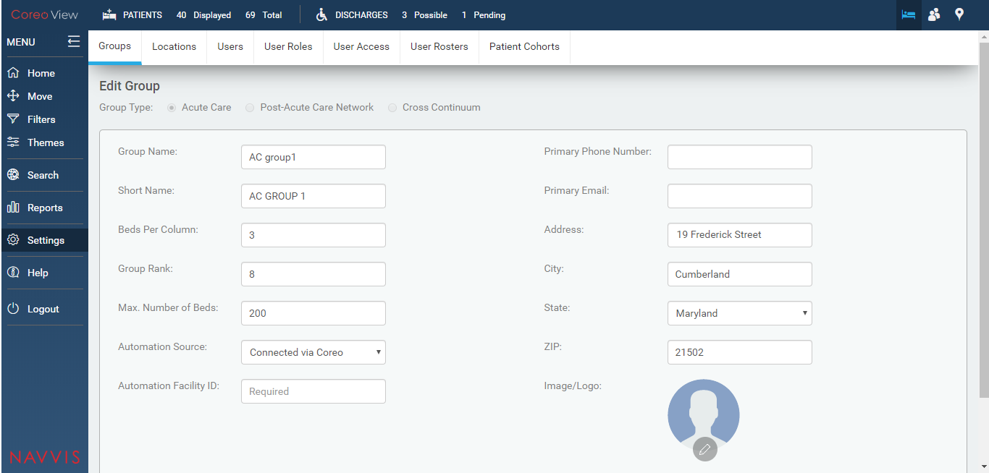
Figure 1: Groups tab page
For the Acute Care group type, enter the following details:
- Enter the acute care group name in the Group Name: field.
- Enter a short name for the acute care group in the Short Name: field.
- View the number of beds allotted for each column for this group in the Beds Per Column: field. You can modify this value.
- View the maximum number of beds that is available for this care group in the Max. Number of Beds: field.
- ……..
- …………
- Step
- Step
Figure xx:
- Step
- Step
- ……..

[If a chapter introduction or a section requires additional context and detailed information to properly prepare the user, extend the information to include tables (such as definitions of the values available in a dropdown). Add captions to identify tables.]
Indicator | Definition
Value 1 | Text
Value 2 | Text
Value 3 | Text
Value 4 | Text
Value 5 | Text
Table X-X:

[Chapter Name / Topic Name]
[Chapter description]

[Section 1] Example: Stage 1 of the process
[Section description]
[Insert the workflow diagram, if applicable]
[Provide examples as applicable.]
[Step-by-step instructions to complete the task.]
- Step
- Step
Figure
- Step
- ……..

[Section 2] Example: Stage 2 of the process
[Section description]
[Insert the workflow diagram, if applicable]
[Provide examples as applicable.]
[Step-by-step instructions to complete the task.]
- Step
- Step
- Step
- Step
Figure
- Step
- ……..

[Section 3] Example: Stage 3 of the process
[Section description]
[Insert the workflow diagram, if applicable]
[Provide examples as applicable.]
[Step-by-step instructions to complete the task.]
- Step
- Step
Figure
- Step
- Step
- ……..

Chapter Name / Topic Name
[Chapter description]

[Section 1] Example: Stage 1 of the process
[Section description]
[Insert the workflow diagram, if applicable]
[Provide examples as applicable.]
[Step-by-step instructions to complete the task.]
- Step
- Step
Figure
- Step
- ……..

[Section 2] Example: Stage 2 of the process
[Section description]
[Insert the workflow diagram, if applicable]
[Provide examples as applicable.]
[Step-by-step instructions to complete the task.]
- Step
- Step
- Step
- Step
Figure
- Step
- ……..

[Section 3] Example: Stage 3 of the process
[Section description]
[Insert the workflow diagram, if applicable]
[Provide examples as applicable.]
[Step-by-step instructions to complete the task.]
- Step
- Step
Figure
- Step
- Step
- ……..

Appendices
[Appendices are optional, and are used to provide additional detailed information that may help the end user manage the overall application. Examples could include references to standards (such as W3C standards), technical specifications required for regulatory compliance, checklists, or other information of a technical nature.]

Glossary
[Glossary term – Description]
[Glossary term – Description]
[Glossary term – Description]
[Glossary term – Description]
[Glossary term – Description]
……………………..

Index
[Depending on the size or complexity of the final document, insert an index to assist the user in locating specific information. Index entries correspond to tags or categories, and are useful in navigating long books.]
[Index term – page number]
[Index term – page number]
[Index term – page number]
[Index term – page number]
[Index term – page number]

[Style Sheet Information]
The following styles have been set up in this template. Avoid applying manual character formatting to the document. Applying these styles will assist in the conversion process if the document is to be laid out in a structured authoring tool, content management tool, or an HTML editor.
Style Name | Apply to
CV Title | Title as listed on the cover page of the document
CV Subtitle | Subtitle as listed on the cover page of the document
CV Front Matter  CV Front Matter 2  CV Front Matter 3 | Copyright and other front matter preceding the Table of Contents;
CV Preface Title | Preface Title
CV Heading 1 | Chapter Name
CV Heading 2 | Section Name for Procedural Steps
CV Heading 3 | Subsection
CV Callout Block Copy Note | Notes, cautions or warnings, use arrow graphic on the left margin
CV Chapter Body Copy | Generic text following heading level 1
CV Chapter Body Copy Indent 1 | Generic text following heading level 2  (Sets additional text inwards to align with level 2 of the heading)
CV Chapter Body Copy Indent 2 | Generic text following heading level 3
Chapter Body Copy – Indent
- Chapter Body Copy – Bullet | Unordered list within a section or subsection, sometimes within a Step to indicate alternative ways to do something, or to list options.
- List Bullet 3 | Unordered list within a section or subsection, sometimes within a Step to indicate alternative ways to do something, or to list options.
- Chapter Body Copy – Bullet 2 | A secondary unordered list, within a higher level ordered or unordered list
- List Number 1  - List Number 2  - List Number 3 | An ordered list (sequential) used in a procedure to indicate the order of actions to be taken
- Chapter Body Copy – Step a | A secondary ordered list, e.g. sub steps in a procedure
CV Table text | Text within a table
CV Table Header | The first row of a table.
CV Table Caption | Descriptive text/Caption for a table
CV Figure | Placement of the screenshots
CV Figure Caption | Descriptive text/caption for a screenshot
CV Page Header – Body Right | Header for odd page numbers.
CV Page Header – Body Left | Header for even page numbers.
CV Odd page Footer | Footer for odd page numbers
CV Even page Footer | Footer for even page numbers
CV TOC Heading | Heading used for Table of Contents
TOC 1 | TOC display information for a chapter. Generated automatically from Heading 1.
TOC 2 | TOC display information for a sub-section. Generated automatically from Heading 2.
[Text] | Text enclosed within the square brackets are template instructions and shall be deleted in the actual user’s guide.

Kindly note: The styles listed above could be subject to certain modifications during the course of content development, based on the depth and dynamics of the content.

